DASAR CSS

EXTERNAL_STYLE
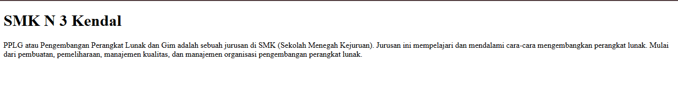
INTERNAL_STYLE

INLINE_STYLE

SELECTOR

MARGIN
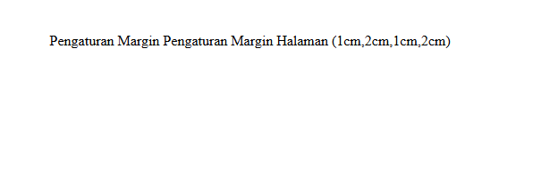
PADDING
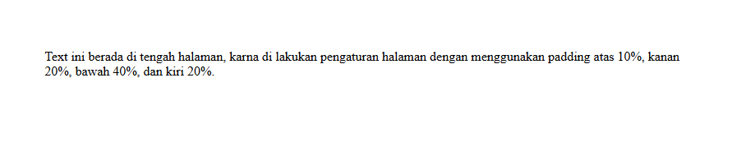
BACKGROUND WARNA1

BACKGROUND WARNA2
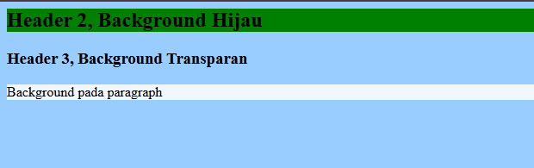
BACKGROUND1
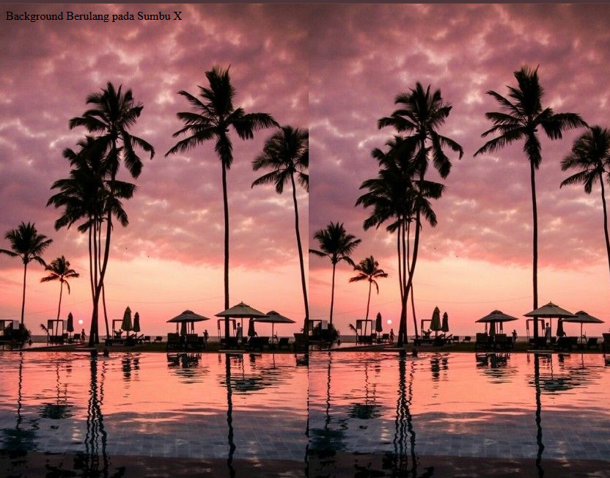
BACKGROUND2
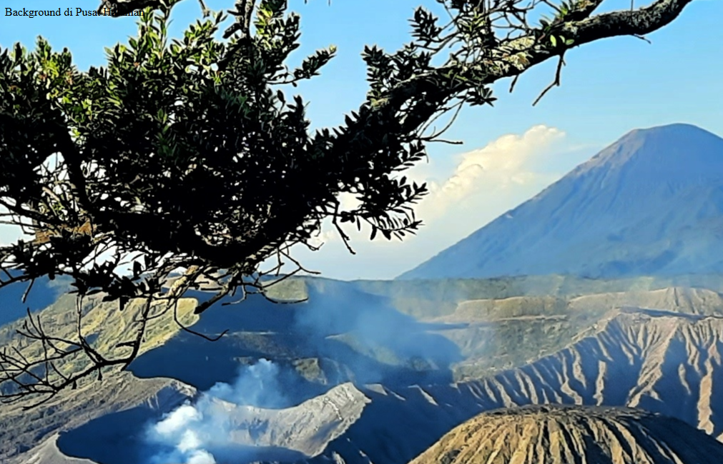
FORMAT_TEXT
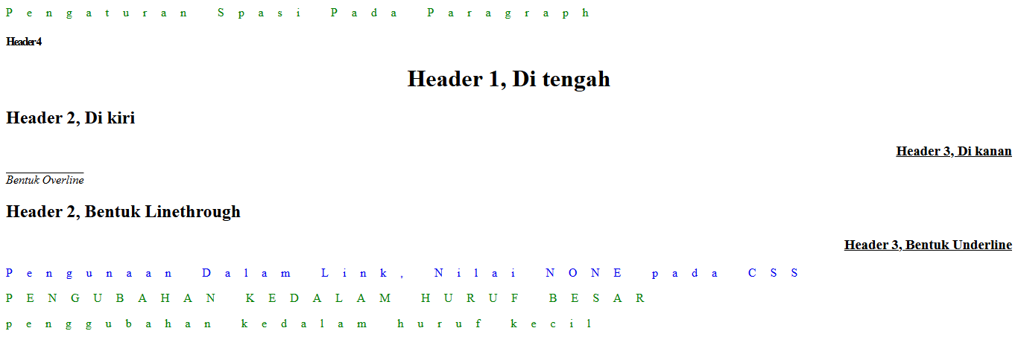
FONT
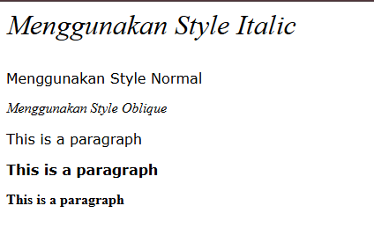
PADDING_TABEL
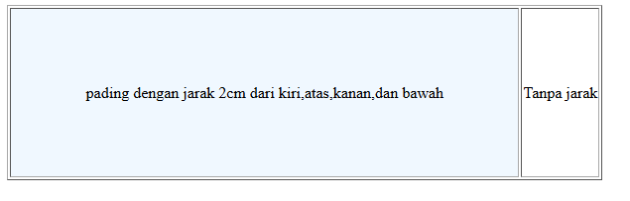
TABEL
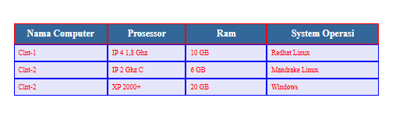
PROPERTY_SELECTOR
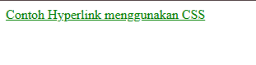
TOMBOL_ANIMASI

TOMBOL_TABEL
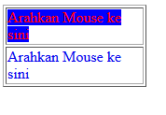
TOMBOL_VISUAL3D


